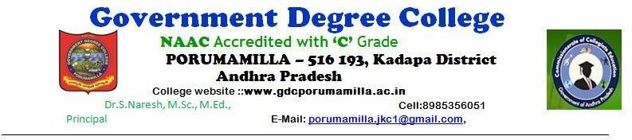

**DEPARTMENT OF COMPUTER APPLICATIONS**

**Student Achievements**

|  |  |  |  |  |  |
| --- | --- | --- | --- | --- | --- |
| **S. No** | **Name** | **Batch** | **Group** | **Present Status** | **Photo** |
| 1 | K. MAHESH BABU | 2019-22 | B.Com CA | Working as PVC  HELPER in Snowbird  Facilities |  |
| 2 | S. MAHAMMAD | 2020-23 | B.Com CA | Working in as Clerk in ICICI Bank |  |

|  |  |  |  |  |  |
| --- | --- | --- | --- | --- | --- |
| 3 | G. AJAY | 2020-23 | B.COM CA | Joined in LLB,  Dr.Ambedkar  Global Law  Institute, Tirupati |  |
| 4 | M.KIRAN KUMAR | 2020-23 | B.COM CA | Employee in South Indian Railways |  |
| 5 | K.NAGENDRA | 2021-24 | B.Com CA | Employee in Quess |  |